**Title of Your Project – Retail Sales Company**

**Bhavya Ogirala**

**November 8, 2022**

1. **Physical model ERD**

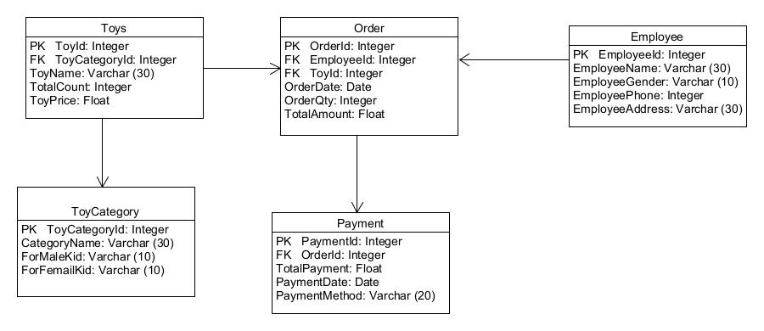

1. **Logical model ERD**

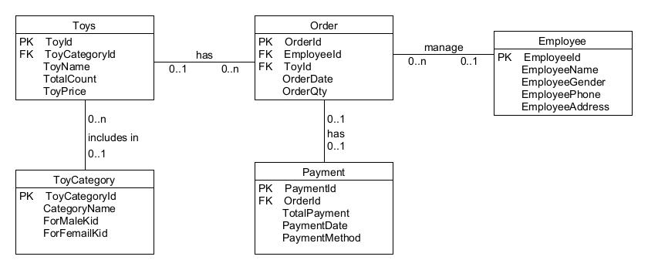

1. **Relationship**

**ToyCategory and Toys**

The cardinality relationship between the ToyCategory and Toys is one to many relationships. A toy category can be assigned to one toy or many toys. The relationship can be retrieved by using the ToyCategoryId.

**Employee and Order**

The employee and the order have one to many relationships. Here, an employee can be assigned to maintain one or more orders. An employee needs to track the order by using the order id.

**Toys and Order**

One to many relationships exist between the toys and order entities. A toy can be ordered once or several times. The same toy can be identified by using the ToyID.

**Order and Payment**

An order is related with one payment only and thus, it is one to one relationship. If an order is placed, then the total amount is calculated for the single order and provided as single payment.